**Education Tool Topics**

|  |  |  |
| --- | --- | --- |
| **1** | The Diabetes Disease |  |
| **2** | Treating Diabetes |  |
| **3** | Monitoring Diabetes | Encourage to act or set goal |
| **4** | Insulin 1 | Provide instruction |
| **5** | Insulin 2 | Provide instruction |
| **6** | Hypoglycemia | Teach to use prompts or cues |
| **7** | Hyperglycemia | Teach to use prompts or cues |
| **8** | Problem Solving |  |
| **9** | Diet |  |
| **10** | Exercise |  |
| **11** | Goal Setting | Encourage to act or set goal |
| **12** | Barriers | Identify barriers  Teach to use prompts or cues  Sick Days & Support |
| **13** | Everyday Life | Work, School, Uni & Driving |

**User Interaction**

At first touch there could be instructions on how to perform the ‘lessons’ and the reward(s) involved in doing so.

The user will scroll through these lessons and will need to signify whether they have read the lessons and thereafter participate in the Q/A.

e.g. have a button saying “next” or “continue” until the lesson finishes unto the Q/A.

There probably should be a function whereby if they guess correct/incorrect, it tells the user immediately.

To avoid reader fatigue, we are going to try and break down the readable content into smaller sections.

To further combat reader fatigue, perhaps having fractional page numbers displayed would encourage continuous reading.

e.g page 1/5

Have minimalist but emotive illustrations throughout.

**Hello and Welcome,**

**to the quiz section!**

**Here there are 13 topics about diabetes and a multiple choice quiz after each reading.**

**It’s important to remember that**

**it’s okay if you do not get all the answers correct!**

**The main thing is that you learn along the way,**

**so you that can better manage your treatment.**

**TOPIC 1 The Diabetes Disease**

**What is Diabetes?**

* Diabetes is when your body cannot manage the levels of sugar in your blood.

**What does Blood Sugar mean?**

* Sugar, also called Glucose, is absorbed by your body from the food you eat.
* Glucose is like fuel for the body because the body needs glucose for energy.
* It gets around the body in the blood and too much or too little sugar in the blood is unhealthy. The amount of sugar in your blood is referred to as your “blood sugar” level.

**What is Insulin?**

* Insulin is made by the pancreas.
* Insulin helps sugar get from your blood into your cells.
* Your cells then use the sugar for energy that your body needs.
* It lowers your blood sugar.

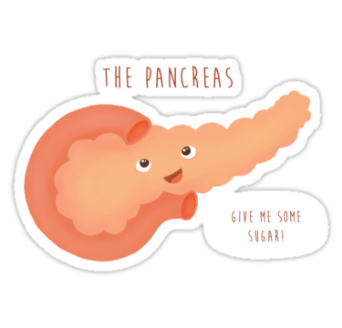

**What is type 1 diabetes?**

* When someone has Type 1 diabetes, the body’s immune system attacks the pancreas until it cannot make enough insulin. Scientists still don’t know why this happens.
* This makes your blood sugar high and your cells very hungry
* Your cells then have to make ketones, as another way of getting energy. Ketones make you feel sick.
* So, we must make sure diabetics get insulin in a different way.

**Are there different types of diabetes?**

Yes!

* **Type 1 Diabetes** is the most common type to affect Aussie kids, teens and young adults.
  + A few things might cause type 1 diabetes, such as genetics, viruses and toxins.
* **Type 2 Diabetes** is the other type of diabetes.
  + It is more common in older people and people who eat unhealthy foods or do not exercise.

**Diagnosing Diabetes**

* Being diagnosed with diabetes can come as a shock.
* However, as you start to learn more about diabetes, you should feel better
* Different people cope differently, and how long it takes for those feelings to resolve is different for each person.

Review Questions

What organ makes insulin?

1. The Kidneys
2. The Brain
3. The Liver
4. The Pancreas

What is the most common type of diabetes that affects young adults?

1. Type 1 Diabetes
2. Type 2 Diabetes
3. Gestational Diabetes
4. Sugar Diabetes

Having type one diabetes means:

1. You eat too much
2. You don’t do enough exercise
3. Your pancreas does not make enough insulin
4. You don’t eat enough sugar

**TOPIC 2 Treating Diabetes**

When you are diagnosed with diabetes you will have it for the rest of your life.

But, the good news is that it can be treated!

**What is the key to diabetes treatment?**

* The key to taking care of your diabetes is to keep your blood glucose as close to normal as possible.
* For most people a blood glucose between 4 and 7 is normal, but your doctor will tell you what blood glucose level is right for you.
* Your goal is to keep your blood glucose as close to this level as you can.
* A blood sugar that is too high is bad, and so is having a blood sugar too low. Both are potentially dangerous.

**How do I check my blood glucose?**

Your doctor or diabetes educator will teach you how to check your blood sugar with a glucose meter (glucometer) at home. Most people have to do this a few times every day.

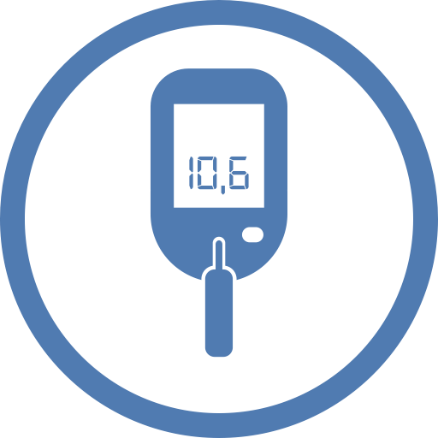

**How do I keep my blood sugar in the right range?**

* In Type 1 Diabetes, insulin injections are needed to control your blood sugar levels.
* Insulin helps glucose get from your blood into your cells. This is good because it lowers your blood sugar, and gives your cells energy.
* You will also need to learn how to use other diabetes medications if you experience a diabetes emergency!

**Are diet and exercise important?**

* Eating well is very important when you have diabetes.
* Because having diabetes means that your body cannot manage the amount of glucose in your blood you have to do the ‘thinking’ for your body. you have to make sure you have enough sugar, but not too much.
* Carbohydrates, or carbs for short, are a good source of sugar for our bodies.
* But if you eat too many carbs at one time, your blood glucose can get too high.
* Exercise is also very important when you have diabetes and so are regular visits to the doctor.

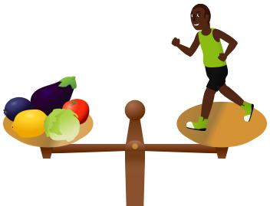

**Why should diabetes be treated?**

* When blood glucose is too high too often, it can harm blood vessels and cause heart attacks.
* It can also damage organs in the body and cause blindness, kidney failure, or loss of toes or feet.
* The good news is that when you take care of your diabetes, you can reduce your chance by having these problems by a lot.
* Do not let diabetes stop you! You can still do all the things your friends do and live a long and healthy life.

Review Questions

What is the normal blood glucose range for most people?

1. 1-2mmol/L
2. 2-5mmol/L
3. 4-7mmol/L
4. 7-10mmol/L

Which of the following are important in the treatment of diabetes?

1. Exercise
2. Having a good diet
3. Learning to use insulin
4. All of the above

If diabetes isn’t treated, which of the following can happen?

1. A medical emergency due to diabetes
2. Vision problems
3. Kidney problems
4. All of the above

**TOPIC 3 Monitoring Diabetes**

* Diabetes is monitored by checking blood sugar levels.
* This is done both by you at home, and by the doctor when you visit them.
* The term Blood Glucose Level (or Blood Sugar Level) is often abbreviated to BSL or BGL. These terms all mean the same thing.
* Recording other factors such as exercise, carbs and insulin also play a role in monitoring.

**Why do we check BSLs?**

BSLs are checked to:

* Work out how much insulin you need to take
* To detect high and low levels
* So you can work out how food and exercise affect your BSLs

**How do I check my BSL?**

* An electronic device called a Blood Glucose Meter or Glucometer is used to check BSLs by analysing a small drop of blood.
* This is done by putting a drop of blood from your finger on a test strip that you insert into the Glucometer.

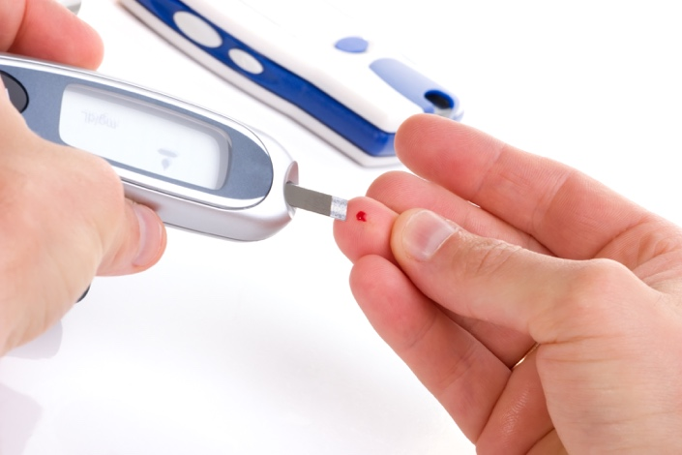

**How do I use a Glucometer?**

1. Wash hands with soap and water, and dry them well
2. Get the glucometer, strips and finger prick ready
3. Prick the side of your finger, and gently squeeze your finger to form a drop of blood to put on the strip
4. Use a tissue to dry the blood on your finger
5. Record your BSL reading on the glucometer in your diabetes logbook or this app
6. Wash hands with soap and water again

**How often should I check my BSL?**

* It is best to measure your BSL 6 times per day.
* You should do this before meals and before you go to bed.
* You should perform additional readings after you exercise or if you feel sick.
* It’s a good idea for you to set a goal of how many times a day you want to check your BSL and stick to it! Other people with diabetes find this really helpful, and reward themselves when they have done their readings. It’s a simple trick to staying healthy.

**What is a Diabetes Logbook?**

* All people with diabetes are recommended to keep a logbook.
* In here you should record your BSLs, how much insulin you take, how much exercise you do and more!
* Some people use paper logbooks and some people use electronic logbooks on their mobile phones.
* This app includes logbook functionality so you don’t have to carry a paper one around ever again!
* You need to keep it so you can see why you BSL goes high or low, and your doctor will be interested in seeing it too.

**How does my doctor measure my blood sugar?**

* When you go to the doctor they will measure your blood sugar just like you do.
* However, they will also test for your glycosylated haemoglobin level - hbA1c for short.
* This tells them what your average blood sugar has been over the last 10 weeks – so you can’t cheat on this test!

Review Questions

How do you measure your blood sugar?

1. With a drop of blood
2. With a drop of urine
3. With blood or urine
4. Only the doctor can measure it

When should you measure your blood sugar?

1. Before you eat
2. When you drink water
3. 30mins after you use insulin
4. When you go to the bathroom

What test tells the doctor how well you have been managing your diabetes over the last ten weeks?

1. The blood test for ketones
2. Testing your blood sugar the same way you do at home
3. The Glycosylated Hemoglobin (HbA1c) test
4. No test can as you can cheat on them all

**TOPIC 4 Insulin 1**

If you have Type 1 Diabetes, you need to use insulin every day.

Insulin is given as an injection – which means inserting a needle just under the skin.

**What types of insulin are there?**

There are two main types of insulin: quick acting (QA), and long acting insulin.

Quick acting insulin is absorbed quickly into the body. It is taken just before or just after a meal so that your body can absorb glucose. It can also be taken when blood sugar is too high. Novorapid is the name used for rapid acting insulin, but yours might have a different name on the box.

Long acting insulin is absorbed slower. This insulin is used to ensure there is always a small amount of insulin in your system so glucose can be absorbed by your cells. Long acting insulin is also called background insulin (BI).

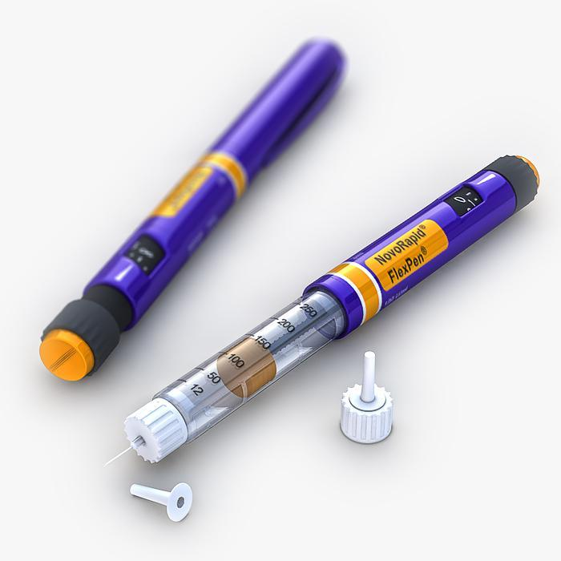

**When do I use Insulin?**

* Your doctor will tell you how much insulin to use, what type to use and when to use it.
* Generally, young adults will need multiple injections of insulin every day. These injections are normally given just before or just after a meal.

**How do I know how much insulin to give?**

Each person has different insulin needs. You will learn to calculate your own requirements with help from your doctor and diabetes educator.

**Long acting insulin is easy because it’s** taken at set times every day. **This one is easy.**

* Quick acting insulin is taken with meals, or to correct a blood sugar that is too high or too low. You can work out how much to take with a meal by:
* Counting how much carbohydrate is in the meal.
* Measuring your current blood sugar. You may need to adjust how much insulin is given if it is too high or low.

**How many carbohydrates are in what I eat?**

* Carbohydrate is the name given to all the sugar in the food we eat.
* When carbohydrates are eaten they are broken down into glucose (a.k.a. sugar) by the digestive system.
* The glucose is then absorbed into the bloodstream and this increases blood sugar levels.
* Many foods contain carbs.
* The amount of carbs can be found by looking at the back of the box you bought the food in.
* If there is no information on the back of the box, you could look it up on the internet!
* 15 grams (15g) of carbohydrates is referred to as 1 carbohydrate exchange.



**REMEMBER: Insulin lowers blood sugar. Carbohydrates raise blood sugar.**

Review Questions

Which type of insulin do most people with diabetes take right before eating?

1. Quick acting insulin
2. Long acting insulin
3. Background insulin
4. Nightime insulin

What are carbohydrates broken down to in the digestive system?

1. Ketones
2. Insulin
3. Glucose
4. Enzymes

Where can I find out how much insulin to use?

1. Searching the internet
2. Reading a book
3. Asking my doctor and reading the information they gave me
4. Asking my friends

**TOPIC 5 Insulin 2**

Content (301 Words)

**Do I need to measure my blood sugar before I give insulin?**

* Yes, always. Otherwise you won’t know how much to use.
* You should have the following targets in mind when measuring:
* BSLs need to be measured at least four times per day
* Before meals your BSL should be between 4-7mmol/L or a correction will be needed
* Before bed your BSL should be between 6-7mmol/L or a correction might be needed.

**Do I need record how much insulin I give?**

* Yes, always write this in your log book

**Where do I inject insulin?**

* Insulin is injected into the fat layer just under your skin.
* You can inject insulin into your abdomen, buttocks and upper thigh.
* If insulin is injected anywhere else, it gets absorbed too fast.
* It is important you use a different spot each time you inject insulin so your skin doesn’t get lumpy or scarred.

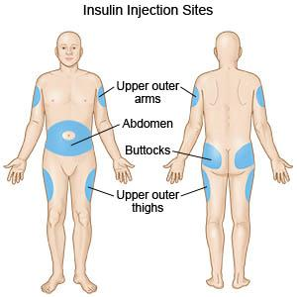

**How do I inject insulin?**

Most people inject insulin using a pen or syringe.

If you use a pen, you should follow these instructions:

1. Wash your hands
2. Measure your blood glucose
3. Check there is insulin in your pen and it is working properly
4. Remove the protective cap
5. Dial up the number of insulin units you need to take
6. Gently pinch up the skin around where you will give the shot and hold firmly
7. Insert the needle using your other hand at a 45-90 degree angle
8. While the needle is in your skin press the button all the way returning to zero, and keep pressing for six seconds
9. Wipe any blood away with a tissue, and replace the needle cap
10. Wash your hands

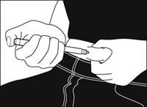

The best way to inject insulin is the way your diabetes educator showed you!

Review Questions

Which of the following is a place where you can inject insulin?

1. Your hands
2. Your feet
3. Your thigh
4. Your calf muscle

What range should your blood glucose be before a meal?

1. 7-10gramsl/L
2. 4-7mmol/L
3. 4-1grams/L
4. 8-3mmol/L

What should you do before you inject insulin?

1. Measure your blood glucose
2. Wash your hands
3. Gently pinch up the skin around where you will give the shot and hold it until the needle goes in
4. You need to do all the above

**TOPIC 6 Avoiding Hypoglycaemia**

Hypoglycaemia – also called a hypo – is the medical word for low blood glucose levels.

BSLs below 4mmol/L are considered low.

**Why are hypos bad?**

A hypo means there is not enough glucose in your blood. This means your brain and other organs can’t get energy when needed. This can be very dangerous.

**What does a hypo feel like?**

Everyone feels different when having a hypo. Some common signs include feeling:

* Sweaty
* Shaky
* Sleepy
* Cross
* Weak
* Like it's hard to concentrate
* Have a headache
* Emotional

**What can cause a hypo?**

* Too much insulin
* Not eating enough carbohydrates
* Skipping meals
* Exercise or sport
* Stress or anxiety
* Sometimes you can have a hypo for no reason at all!

Common times for hypos are just before lunch and during and after sport. They can also happen during the night if your blood sugar is too low before you go to bed.

**What should I do if I think I’m having a hypo?**

If you feel like you are having a hypo, the first thing you should do is always eat or drink something sweet. Appropriate sweet foods are fast acting carbohydrates, such as:

* ½ glass of fruit juice, cordial or soft drink
* 4 large or 7 small jelly beans
* 3 teaspoons honey or sugar

The second thing you need to do is check your BSL. If you are having a hypo it will be below 4.

After 15 minutes, you should have a long-acting carbohydrate to stop the hypo from coming back, like:

* A piece of fruit,
* A slice of bread,
* Two biscuits, or
* A glass of milk.

Finally, it is important to check your BSL a second time 15-30mins later. It should be improving. If hypoglycaemia is left untreated or does not improve you may fall asleep or have a fit.

**I don’t feel like I’m having hypo but my BSL is below 4, am I having a hypo?**

* Yes, and you need to treat it like you are.

**If I test my blood sugar before I eat, like I normally do, and my sugar is below 4, what do I do?**

* You are having a hypo.
* In this case you need to eat or drink something sweet then eat your meal 15mins later.
* You shouldn’t take short acting insulin with your meal.

**What are some tips for avoiding hypos?**

* Test your BSL before you eat and before bed
* Watch out for hypos when exercising, it’s a good idea to have a snack beforehand
* Calculate the insulin required with each meal carefully
* Record your insulin doses and BSLs in your diabetes logbook so you can see patterns in your sugars. Many young adults find this helps them.

**What are some tips for when I do have a hypo?**

* If you are worried, eat something sweet
* Tell somebody in case it doesn’t improve
* Write down what happened in your logbook
* Don’t forget to always carry hypo foods with you

Review Questions

Which of the following actions might cause you to have a hypo?

1. Not having your insulin with breakfast
2. Skipping lunch
3. Eating too much
4. Not having enough insulin with dinner

Which of the following is an example of someone having a hypo?

1. Somebody who is tired after exercising with a BSL of 5.3
2. Somebody who is at home sick with the flu with a BSL of 8.1
3. Somebody who forgot to take their night-time insulin with a BSL of 12.0 in the morning
4. Somebody who feels emotional with a BSL of 3.1

What should you do first when you think you are having a hypo?

1. Have a banana
2. Drink some lemonade
3. Inject short acting insulin
4. Drink water

**TOPIC 7 Hyperglycaemia**

Hyperglycemia is the medical term for high blood glucose levels. Blood levels above 7mmol/L are considered high.

All young adults with diabetes have some blood glucose levels above the target range. This is not a problem if the majority are within the target range.

**Does hyperglycemia make you feel sick?**

* It is possible for your blood sugar level to be high without you realising.
* Many people do not feel sick until their blood sugar levels are extremely high (above 15mmol/L).

**What might I feel like when my blood sugar is too high?**

Some of the signs include feeling:

* Feeling excessively thirsty
* Frequently needing to wee
* Feeling tired
* Blurred vision
* Weight loss
* Hunger
* Mood changes

**What can cause high BSLs?**

* Ilness
* Infection
* Stress, worry and anxiety
* Too many carbohydrates at once
* Not enough insulin
* Less exercise than usual

**What short-term problems can occur with hyperglycaemia?**

If hyperglycemia is left untreated ketoacidosis may develop.

Ketoacidosis (DKA) is a serious condition associated with illness or very high blood glucose levels in type 1 diabetes.

* It develops gradually over hours or days. It is a sign of insufficient insulin.
* Without enough insulin, the body’s cells cannot use glucose for energy. To make up for this, the body begins to burn fat for energy instead.
* This leads to accumulation of dangerous chemical substances in the blood called ketones, which also appear in the urine.

Signs of DKA include: rapid breathing, flushed cheeks, abdominal pain, vomiting and dehydration.

**What long-term problems can occur with hyperglycaemia?**

When blood glucose is too high too often, it can harm blood vessels and cause heart attacks. It can also damage organs in the body and cause blindness, kidney failure, or loss of toes or feet.

**What do I do if my blood sugar is too high?**

If your blood sugar is too high, you need to lower it by adjusting the amount of insulin you take with your next meal. You also should drink plenty of fluids because hyperglycaemia can make you dehydrated.

If your blood sugar is very high (above 15mmol/L) you need to check for ketones as well. You can do this by testing your urine with strips, or by using a special glucometer with a drop of blood.

* If you have lots of ketones in your urine (above 1.5mmol/L), you are in the early stages of DKA. You need to call your diabetes educator to work out how much extra insulin you need to take.
* If you don’t have lots of ketones, keep checking your BSL and ketones every 2 hours until your BSL is below 7. Do not exercise if your BSL is above 15mmol/L or ketones are present.

Review Questions

If you skip your morning insulin and have breakfast your blood glucose level will usually:

1. Be too low to measure
2. Increase
3. Decrease
4. Stay the same

If your stopped taking your insulin for 2 days and tested your blood sugar and it was 16mmol/L, what should you do?

1. Drink water
2. Test for ketones immediately
3. Consider eating and taking extra insulin
4. All of the above

Which of the following is an example of someone who needs to take extra insulin with their next meal?

1. Somebody who feels tired with a BSL of 11.1
2. Somebody who is vomiting with a BSL of 7.2
3. Somebody who sweaty with a BSL of 5.5
4. Somebody who is vomiting, with no ketones, and a BSL of 3.0

**TOPIC 8 Problem Solving**

Everyone who has diabetes eventually has some problems with their BSLs.

In this topic, we will consider some examples of how common diabetes problems can be solved.

**Katie’s Story**



Katie has type one diabetes and lives in Brisbane. Usually, her blood glucose is fairly well controlled. However, she sometimes has problems with low blood sugar.

For example, she recently went on a weekend trip with friends. While she was away, her blood sugar went so low that she felt like she was going to pass out. When she drank some cordial, she felt better and her blood sugar rose from 2.4 to 6.2mmol/L.

There are many possible causes of low blood sugar. When you are trying to figure out which cause applies to you, it helps to have good records of your monitoring results. This is why you need to use a logbook, or an app like this one, to record your blood sugar readings.

The day after Katie's hypo, she thought about what could have led to her very low blood sugar..

* Katie knows that she has high stress when she travels, and that often raises her blood glucose, so gave herself a little extra insulin.
* Then she had gone swimming with her friends, and walked more than usual.
* She drunk some alcohol at dinner, which can lower blood sugar.
* And she thinks she may have used too much insulin before dinner, as she didn’t end up finishing her whole meal.

Any one of these alone might have caused a mild hypo for her. But all together these events caused severe hypoglycaemia.

**Andrew’s Story**

Andrew has type one diabetes and lives in Logan. Unfortunately, Andrew’s BSLs have not been well controlled this month. His blood sugar is sometimes too high and sometimes too low.

When Andrew looks at his logbook he sees that his BSLs are often too high in the morning and then too low around dinner time. This makes it very difficult for him to calculate the correct insulin dose.

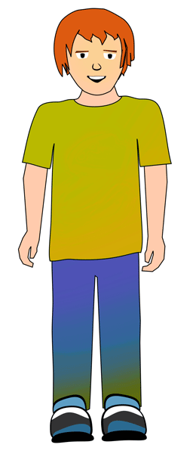At his next doctor’s appointment, Andrew asked the doctor what might be happening. After looking at his logbook the doctor told Andrew his insulin dose with meals might be too high for him!

The doctor explained that if too much short-acting insulin is taken, you are most likely to have a hypo around 6 hours later (but as long as 12 hours later). The doctor was also able to adjust Andrew’s insulin to carb ratio and night time insulin, and now his control is much better. Because of this, he is at a much lower risk from having a hypo or being at risk from other serious diseases.

**Problem Solving**

Most diabetes problems have possible solutions. Good solutions need to fit each person, and that may require some creativity.

Fortunately, effective problem-solving can be helped by:

1. Keeping an accurate logbook, recording BSLs, insulin doses and time spent exercising
2. Checking your BSL if you feel sick, skip a meal, or before you take any insulin

Review Questions

You realize just before dinner time that you forgot to take your insulin before lunch. What should you do now?

1. Skip dinner to lower your blood glucose
2. Take the insulin that you usually take at lunch
3. Take twice as much insulin as you usually take at lunch
4. Check your BSL so you can calculate exactly how much insulin to take

Which of the following will most likely cause low blood sugar?

1. Not enough insulin
2. Exercise
3. Too much food
4. Stress

What information should be recorded in your diabetes diary?

1. Results of blood sugar checks
2. Adjustment insulin doses
3. Time spent exercising
4. All of these

**TOPIC 9 Diet**

Managing diabetes however is not simply about insulin and blood sugars. Diet is also a very important part.

Young people with diabetes are told again and again – manage your diabetes or else you will have complications like kidney damage. It’s really hard to wrap your head around this logic, since these long-term problems feel like they are too far off to matter.

However, there are good reasons that you should maintain good control in the short term that are often forgotten about – for many people maintaining good blood sugars makes them happier and more energetic.

Diet plays a big role as well, especially for maximising these short-term benefits. The next few pages will answer some common questions about food and diet asked by young people with diabetes.

**Do I have to eat differently because I have diabetes?**

* No, you don’t.
* You should eat a ‘healthy’ diet. This will make it easier to control your BSLs.

**What is in food?**

* Foods supply us with energy (calories, kilojoules).
* We obtain nutrition through the foods we eat.
* To keep your body running, you need three main types of nutrients:
* Carbohydrate
* Protein
* Fat
* Many foods have a combination of all three types of nutrients, and all give you energy

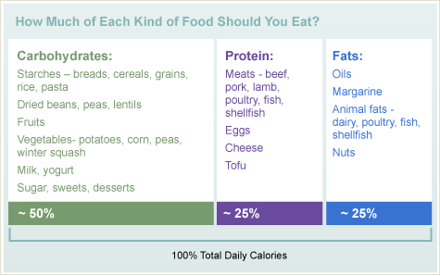

**What are carbohydrates?**

* The carbohydrates in food, or carbs for short, come in all different sizes – big and small
* The smallest carbohydrate is glucose (sugar)
* All carbohydrates are broken up into smaller bits - of glucose - before they are absorbed by your body

**Why are carbohydrates important for people with diabetes?**

* As a diabetic, you need to pay close attention to how many carbs are in what you eat – because that’s how you work out how much insulin to take.

**What is a carbohydrate exchange?**

* 15 grams (15g) of carbohydrates is referred to as 1 carbohydrate exchange.
* When most diabetics eat a meal, they need to take a certain number of short acting insulin units for each carbohydrate exchange.

**How much carbohydrate do I need to eat each day?**

* Carbohydrates generally provide 45-65% of your daily energy.
* For most young adults with type 1 diabetes, this ranges from 150-250 grams of carbohydrate a day.

**How much carbohydrate is found in the foods I eat?**

* There are many resources you can use to count carbohydrates:
* Nutrition Facts food labels on packaged foods list the total grams of carbohydrate.
* The American Diabetes Association [Exchange Lists for Meal Planning](https://dtc.ucsf.edu/pdfs/FoodLists.pdf):
* The Queensland Health [Carbohydrate Guide Online](https://www.health.qld.gov.au/nutrition/resources/diab_chocount15g.pdf)
* Apps for your phone

Below are some examples of what 1 carbohydrate exchange (15g) can look like:

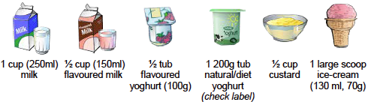

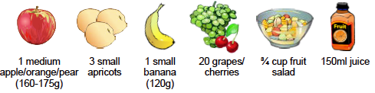

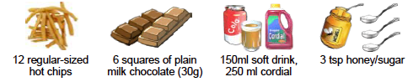

**What foods contain carbohydrates?**

* Rice, grains, cereals, and pasta
* Breads, tortillas, crackers, bagels and rolls
* Dried beans, split peas and lentils
* Vegetables, like potatoes, corn, peas and winter squash
* Fruit
* Milk
* Yogurt
* Sugars, like table sugar and honey
* Foods and drinks made with sugar, like regular soft drinks and desserts

**Do I need to take extra insulin when I eat Fibre?**

* Fibre is a complex (too big to be broken down) carbohydrate found in fruit, vegetables and whole grains.
* However, fibre is not absorbed by your body when you eat it
* This means you do not have to take insulin to cover fibre.

**What are some tips for best controlling my blood sugar with diet?**

* Eat three meals a day, roughly 4-6 hours apart
* Do not skip meals
* Try to consistently eat the same amount of carbohydrate at each meal
* If you don’t finish your meal but have already given your insulin, try having a small carbohydrate snack before your next meal
* If you have more carbohydrate with a meal than you planned, consider taking more insulin
* Nutritious, high fibre, low fat foods (they are absorbed slower - generally fruits, wholegrains and dairy) will make you feel less hungry your blood glucose levels, and prevent glucose highs and glucose lows.

Review Questions

Carbohydrates are found in which foods?

1. Fruit, milk, and starchy vegetables
2. Cheese, steak, and chicken
3. Olive oil, butter, and fish
4. Egg, vegemite, and mince

Which of the following is true?

1. 10% of your daily energy comes from carbohydrates
2. Sugar is a carbohydrate
3. Kids with diabetes should avoid eating carbohydrates
4. Fat is a type of carbohydrate

You are reading the food label below to work out how much insulin to take with your lunch. If you had one serve of this food, how many carbohydrate exchanges are you eating?

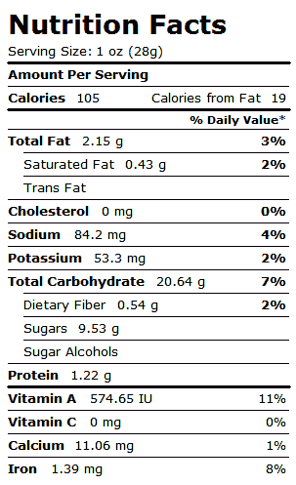

1. About 1.0
2. About 1.4
3. About 2.8
4. About 10

**TOPIC 10 Exercise**

We all know that physical activity is good for us. But many young people with type 1 find it makes managing their sugars difficult. As a result, many young people lose confidence and stop playing sport or exercising.

It is sometimes easy to forget that if you don’t exercise it can make it harder to control your blood sugars. It also stops you from gaining weight, which can make it much harder to manage your diabetes.

**How much exercise should you do?**

* This depends on how old you are.
* People under 18 should exercise or play sport for at least 60 minutes every day.
* People 18 years or older should exercise or play sport for at least 30 minutes every day.



**What effect does exercise have on insulin?**

* It will help your insulin to work more effectively and assist with your blood glucose control.

**What effect does exercise have on blood sugar?**

* Exercise usually lowers your blood sugar.
* Hypos caused by exercise may occur up to 24 hours later.
* To stop your blood sugar from going to low, it is important to have extra fast acting carbohydrate drinks or snacks before activity, and every 30 minutes during long games of sport.
* Very demanding exercise might actually increase your blood sugar. However, this doesn’t last long, as it normally drops soon after you finish exercising.

**When should exercise be avoided?**

* If you feel sick
* If your BSL is higher than 14mmol/L and you have ketones
* If your BSL is less than 4mmol/L

**Should I take extra insulin before I exercise?**

* You should never take extra insulin before you exercise. This would make your blood sugar drop too low!
* A lower dose of insulin may be needed when you are active, and meal insulin doses decreased just before and just after the activity.
* Exercising every day may require an overall reduction in your total daily insulin dose.

Review Questions

What effect does moderate exercise usually have on BSLs?

1. It causes insulin to stop working
2. It raises BSLs
3. It lowers BSLs
4. It has no effect on BSLs

How much extra insulin should be taken before exercising for 30mins?

1. 2 Units
2. 4 Units
3. 8 Units
4. NO extra insulin should be taken because of exercise

What effect does exercise have on insulin?

1. Routine, daily exercise will not affect how much insulin you need to take
2. A higher dose of insulin may be needed when exercising
3. It makes insulin work less effectively
4. Exercise done at the same time, with the same duration and intensity every day will ensure the most predictable blood glucose responses.

**TOPIC 11 Goal Setting**

Having goals is useful for young diabetics with busy lives. It is often difficult to think about what your BSLs, insulin doses and test results mean when you see them.

Goals make it easier to understand the impact of these individual numbers, as you can see if you are meeting the targets that are important to you.

**What diabetes related goals are worthwhile setting?**

This is a difficult question to answer, because different things are important to different people.

Some of the more common goals that people set are:

* Keeping a certain percentage (e.g. 80%) of BSLs in range
* Trying to keep one BSL reading taken at the same time each day (e.g. before lunch, when waking up) in range
* Improving their HbA1c compared to their last reading
* Exercising for a certain amount of time each week

**What makes a good goal?**

There are many qualities of a good goal, including:

* That it must be **specific**. For example, reduce blood sugar, or keep blood sugar within range.
* It must be **measureable**. For example, keep 80% of blood sugar readings in range over two weeks, or exercise for 120 minutes this week
* It must be **realistic**. Don’t pick a goal that won’t work for you, and don’t pick a goal that is too hard. Taking small steps is important!
* It must be **time-related**. Specify when you should achieve your goal by, for example, in four weeks’ time I want to be doing at least 30 minutes of exercise per day.

**BSL Problem Solving**

Controlling your diabetes means maintaining the proper balance between insulin dose, food and activity every day. It’s easier said than done – and for people struggling to keep their BSLs in range, they need to problem solve.

To problem solve blood sugars that aren’t always in range you need to know:

* Your blood glucose readings
* Your carbohydrate intake with each meal
* Your insulin doses
* And potentially when you did exercise and how much as well

Therefore, it is useful to keep a logbook, as it contains all this information.

This app includes logbook functionality so you don’t have to carry a paper one around ever again!

**Identifying BSL Problems**

Having this information allows you to problem solve. You can do this by:

1. **Dividing the day into zones** (morning, afternoon, night etc.)
2. **Identifying strengths.** When are you on target?
3. **Identify any problems**. When are you either too high or too low?
4. **Look for patterns.** Do problems with high or low blood sugar pop up at the same time each day? After you eat? After you exercise? When you’re relaxed? After you use insulin? When you’re stressed?

**Fixing BSL Problems**

After you think you’ve identified a reason why your BSLs are out of range, you need to work out how you think might fix it.

For example, do you need to eat some more before exercise or change how much insulin you take with meals. When you are making a change, ensure that you:

* Make one change at a time
* Verify that what you’re changing fixes the problem
* Talk to your diabetes team – they can help you analyse your data

**Is keeping my HbA1c low a good goal to have?**

HbA1c is a test of what average blood sugar has been over the last 10 weeks. Keeping this below 7% (or 7.5% if you are under 18) is a very good goal to have.

If your HbA1c is low, it means your diabetes control is excellent.

Review Questions

A low BSL after a meal may be caused by:

1. Incorrect carbohydrate counting
2. Too much mealtime insulin
3. A high fat and/or high protein meal
4. Any of the above

In general, low blood sugars are caused by:

1. Exercise / Increased activity
2. Not eating enough carbs
3. Too much insulin
4. Any of the above

What is the target HbA1c for most adults?

1. 10%
2. Below 4%
3. Below 7%
4. 5%

**TOPIC 12 Barriers**

**Who can I contact for help?**

There are many people that can be contacted for help if you have questions about your diabetes.

Most hospitals have diabetes educators that can be contacted if you have questions about BSLs and insulin. At your next diabetes specialist (doctor) appointment, you can ask about these services.

In emergency situations, you can also contact the hospital, or call 000 if it is life threatening.

Other professionals, such as your GP and psychologists can also be helpful in managing specific issues you may have – such as anxiety about your condition, and questions about diet and exercise.

Your diabetes educator may also know of some support groups and hotlines that you can use as well if you are interested.

**What issues do adolescents with type one most commonly face?**

There are a lot of things that makes managing diabetes harder.

A lot of adolescents and young adults face problems with getting support from family, friends, work, school and uni – sometimes people find it difficult and embarrassing to ask for help, and sometimes help is hard to find!

Others have difficulty managing the number of injections they should take per day, because it can be hard to find time or find the money to pay for insulin.

It is always helpful to think about these things and try to identify your individual barriers. Often your doctor will be able to give you some advice at your next appointment – no-matter what the issue is.

**What do others say?**

Below are some good quotes from other young people with diabetes. Remember you aren’t alone, and it’s tough sometimes!

*“I have to check my sugar and count my carbohydrates before every meal. I always need to have my meter and wear identification. I have so many doctors’ appointments, It’s ridiculous.”*

*“I know what I should do, but I just can’t seem to do it. Maybe I don’t have the energy; maybe I don’t care.”*

*“First it takes 20 minutes before I finally get transferred to the right person. It took another 2 months before I got an appointment with the doctor. Then all the doctor did was look at my logbook and tell me my numbers were too high. I felt lousy.”*

**How can prompts and cues help me?**

For people who are forgetful or busy, prompts can help. A prompt is something you use to help you remember to do something. A prompt is also called a cue.  
  
We have found the following prompts to be helpful:

* Use an app or alarm on your phone to remind you to test your BSL before bed and when you wake up
* Set an alarm on your phone for the day before each appointment you have at the hospital to remind you
* When you feel hungry, eat and test your blood sugar at the same time
* Keep your glucometer near your food so you remember to test your sugars

**How do I manage my BSLs when I get sick?**

Young people with diabetes do not get sick more often than others. But when they are sick managing their sugars is hard.

Being sick with a virus, cold, or infection can cause your blood sugar to go high OR low.

When you are sick, this is how you should manage your diabetes:

* Visit your GP if you are concerned about your illness, for example if you have a cough that won’t go away.
* Call 000 in an emergency.
* Use Panadol for pain or fever.
* Drink more fluids. If your BSL is higher than 12 mmol/L drink water only.
* Rest
* Check BSLs every 2-4 hours
* Check ketones at least once per day when sick.
* Do not skip insulin if your BSL is low. Some insulin is always required.

**High BSLs when Sick**

If your BSL is above 15mmol/L and moderate or high ketones are present, give an extra dose of quick acting insulin (e.g. novorapid) equal to **10%** of all the insulin you usually take in a day. Extra insulin can be given every 2-4 hours.

DKA is more likely when you are sick. If ketones and BSLs are high you are at high risk of going into DKA (ketoacidosis – a serious condition). The signs of DKA include nausea, vomiting, and abdominal pain.

**Low BSLs when Sick**

If BSLs are low (below 5mmol/L), you may reduce long acting insulin by up to 50%. Quick acting insulin should not be taken if you are not eating and drinking things containing carbohydrates.

If you can’t keep your sugars in the normal range, or you have ketones, you need to ring the hospital.

Review Questions

If you are sick and cannot eat, you should:

1. Not take any insulin
2. Test your blood sugar more often
3. Double your insulin
4. Only drink water

If you are sick and your blood sugar is 17mmol/L, you should:

1. Double your insulin
2. Only drink juice
3. Check for ketones
4. Not take any insulin

Which are the following are barriers commonly faced by young people with diabetes?

1. Difficulty finding the time to measure BSLs and calculate insulin doses
2. Difficulty finding the money to pay for insulin
3. Anxiety
4. All of the above

**TOPIC 13 Everyday Life**

Managing diabetes can make everyday tasks more challenging. Some good examples and strategies to manage them are discussed here.

**Work**

Because many young people with diabetes work with few or no restrictions, their employers don’t even know that they have diabetes.

It is probably wise to give workmates a simple explanation about diabetes so that they learn more about diabetes and understand what is happening to you if you suddenly need to eat or get insulin.

It would be wise to make sure one or two key people know what to do in the event of you having a hypo. This however is your personal choice.

**School**

Young people with diabetes can participate fully in school life.

However, there are aspects of school life that can affect diabetes, for example sports, break times, school camps and exams. Because of this, it’s important that your school knows you have diabetes.

Everyone has individual issues they must work through at school. For example, finding a private place where you feel comfortable injecting insulin, or where to put your needles after use. Speak to your diabetes educator about this and they can give you some useful strategies.

**Uni**

The challenges in managing diabetes at uni are different to those at school.

You need an appropriate place to store insulin, and make sure you don’t have too many classes in a row so you have a break to eat and take your insulin.

Most unis in Queensland provide help through student services for people with diabetes. This can include arranging a place for you to store insulin, as well as allowing you extra time during an exam so you can take a break to eat.

**Driving**

If you have diabetes you can drive if your diabetes is well managed. The main concern is the possibility of having a hypo while driving.

Hypoglycaemia can impair your ability to drive safely. Ensure that you always have a carbohydrate snack available in your car.

If you feel like your BSL is low, pull over immediately and stop your car. Do not restart the car until you have treated your hypo and feel absolutely normal.

If you have diabetes you must tell Queensland Transport and your insurer, even if you were diagnosed after you got your licence. If not, there may be difficulties if you are in a crash.

**Alcohol**

Drinking alcohol can be a problem for young people with Type 1 diabetes as it increases the risk of having a hypo.

When you are out drinking with friends it is often easy to forget to eat as well. This is another risk for having a hypo.

There are some important things to remember about drinking:

* People under 18 shouldn’t drink
* If you do drink it’s best you tell your doctor at your next appointment so you can work out a plan of how to manage your sugars when you do
* Have some carbs before drinking alcohol and every couple of hours while you are, and then again before bed.
* Test your BSLs, especially before bed, and continue to monitor the next day to detect a hypo early.
* For each alcoholic drink you have, have a glass of water.
* Tell a friend who is with you what to do in an emergency.
* Wear a medic alert bracelet when you do drink so people know you are diabetic in an emergency.

Review Questions

If you have a headache and are tired when driving, what should you do?

1. Pull over and check your BSL
2. Drink a glass of water
3. Text a friend and tell them what’s happening
4. Wait 15mins and see if it goes away

Drinking alcohol lowers your blood sugar because:

1. You might forget to eat
2. Alcohol has a direct effect on your body causing your blood sugar to drop
3. Both of the above
4. None of the above

Which of the following is true?

1. You must tell your boss, if you work at a restaurant, that you have diabetes
2. You must tell the Queensland Transport that you have diabetes
3. It is not a good idea to tell any of your friend you have diabetes
4. It is not a good idea to tell your school or uni that you have diabetes